**Window Server 2012 – Documentation**

Shawn Shahi

**How to Launch Windows Server 2012 R2 from Amazon Web Services**

Step 1: Successfully create an AWS Account using your school email and receive $60 of credit for FREE!

Step 2: From the AWS Management Console 🡪 SELECT EC2.

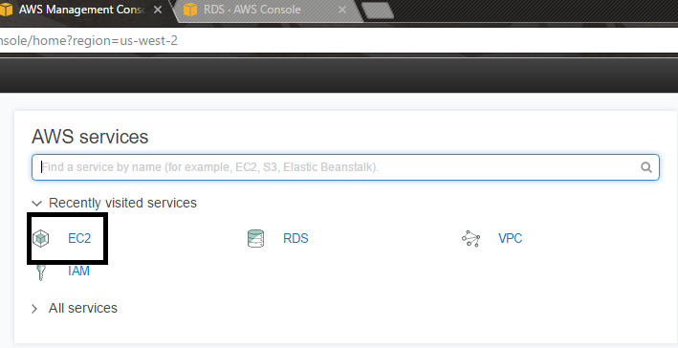

Step 3: Select Instance from the left and click “Launch Instance,” as shown below.

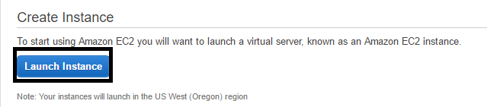

Step 4: Select Microsoft Windows Server 2012 R2



Step 5: Configure the AWS Instance to a VPC that has been created by Default.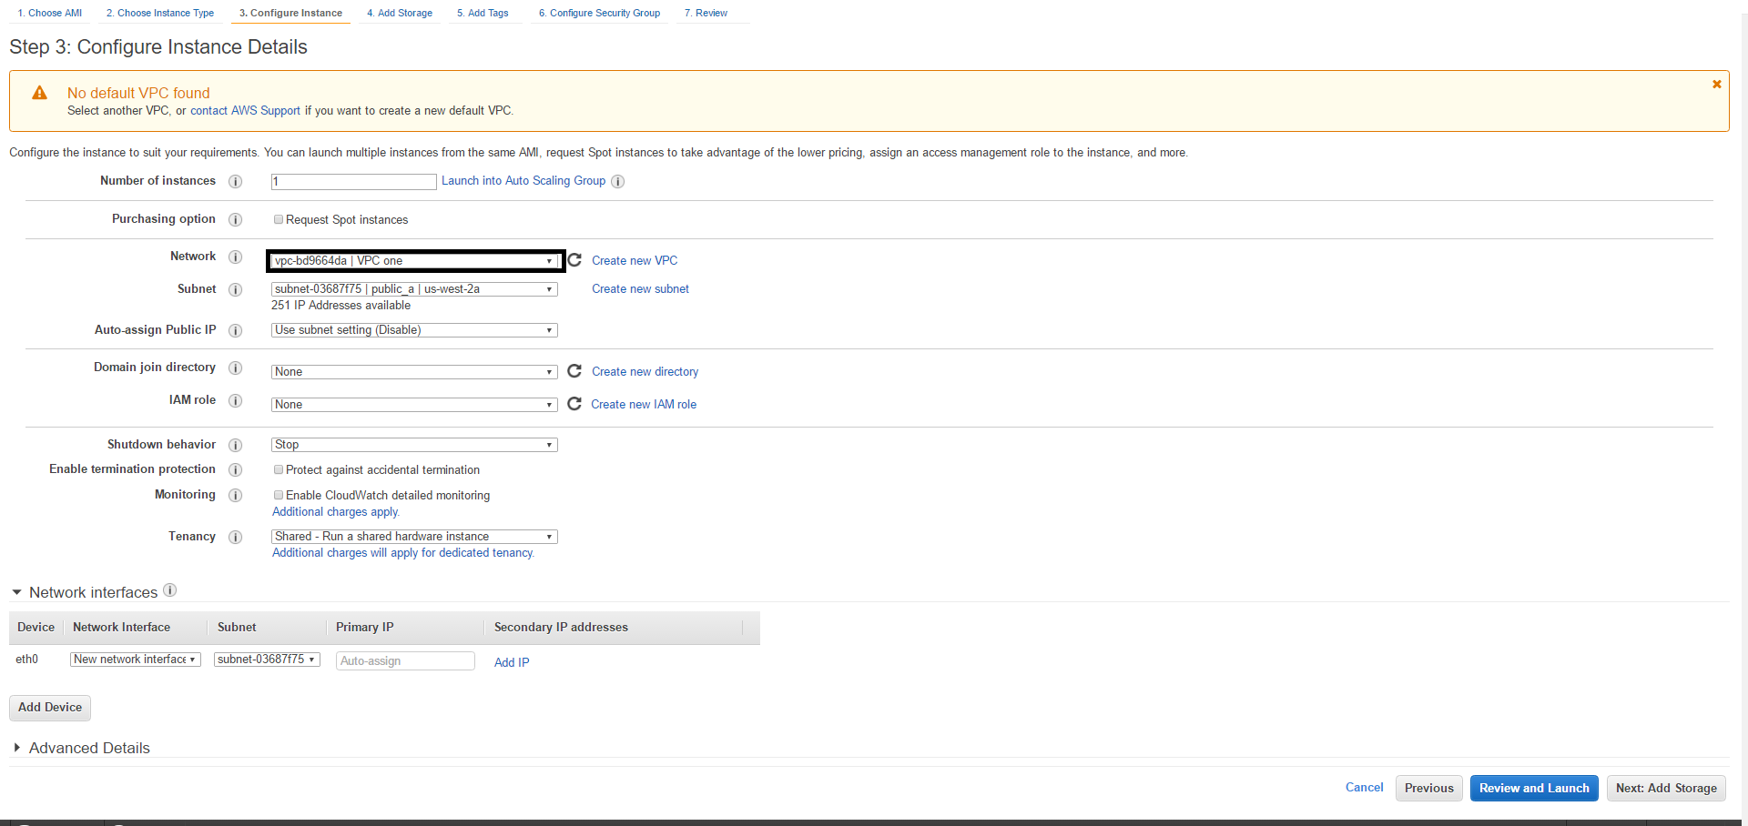

Step 6: Select the “Add Rule” button to add: HTTP & HTTPS

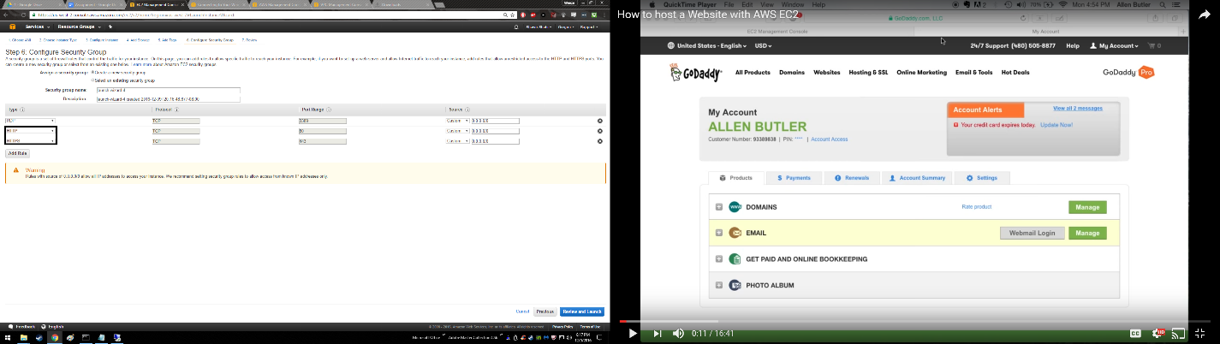

Step 7: Review all your changes and select “LAUNCH.”

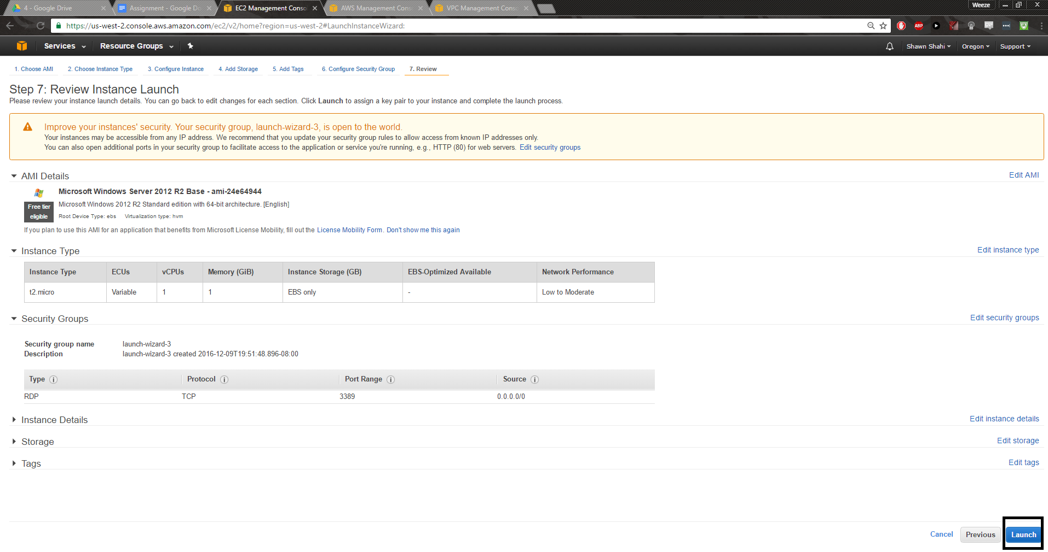

Step 8: After about 5 minutes of the instance being launched, select “Connect.”

A new window will pop up and you must then select a .pem file that contains your key.

Select Decrypt Password

NOTE: IF YOU DO NOT HAVE A KEY, VISIT THE FOLLOWING LINK REGARDING DOCUMENTATION

<http://docs.aws.amazon.com/AWSEC2/latest/UserGuide/ec2-key-pairs.html>

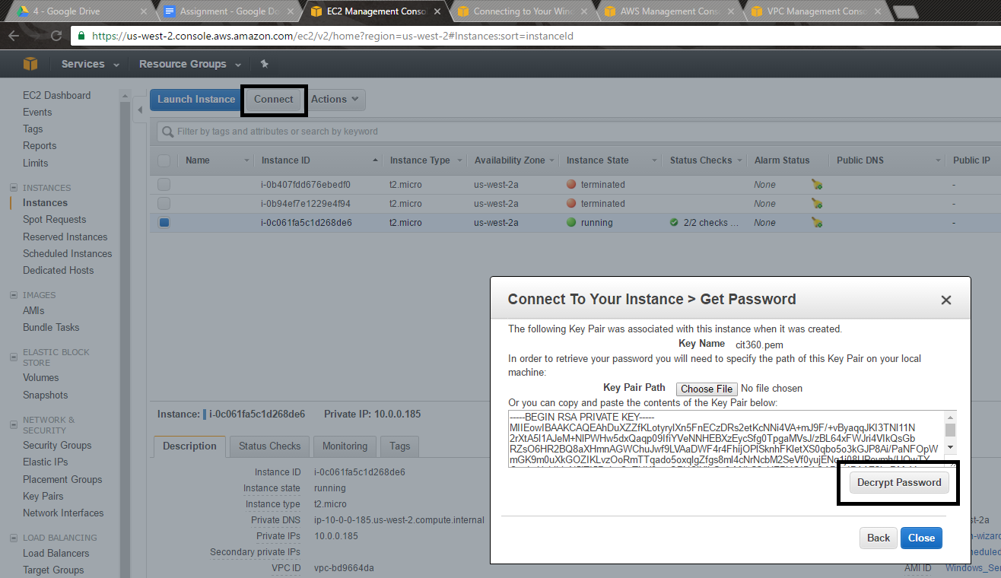

Step 9: Your login information will be shown, please store it for future use.

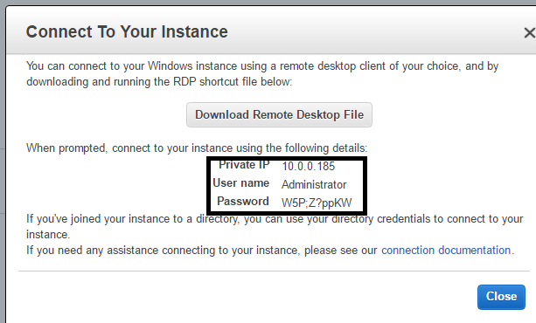

Step 10: Login to the Terminal and.. CONGRATZ YOUR ARE IN YOUR SERVER!!!

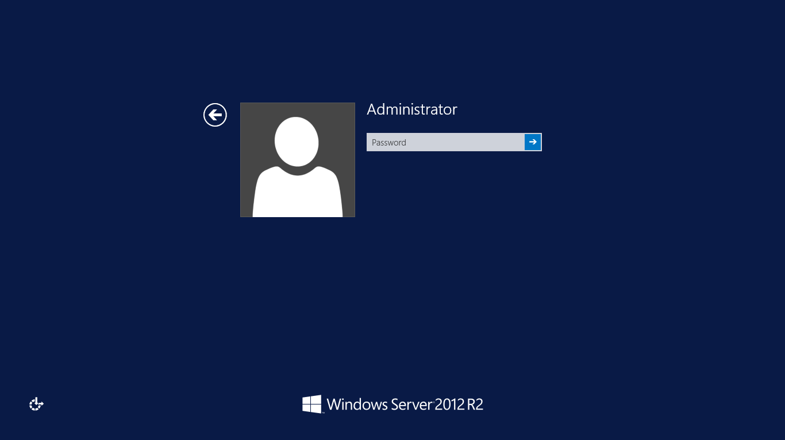

Step 11: From the left hand side, open the taskbar and select “Server Manager”.

NOTE: You may also search for it as well.

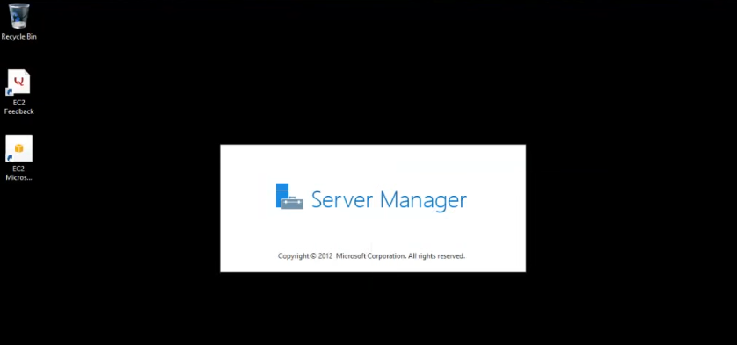

Step 12: And WALAH! You are in the GPO Menu and may change whatever you like!

